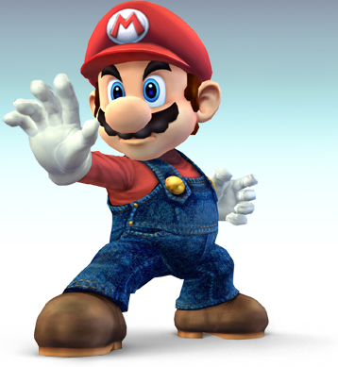
GET SMASHED
Super Smash Bros Melee Tournament
Prizes and snacks
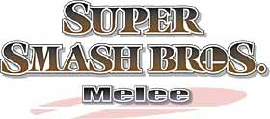
8:00 Pm Saturday 3.3.12 main lobby

